CORE JAVA
Please make sure to save/push all your code in the branch feature-java created in the previous week assignment as part of your github repo rg-assignments

Please share your output screenshots in the assignment document along with the github link for each question. Provide an explanation wherever possible as part of your response :-)

Given:
public class TaxUtil {
double rate = 0.15;

public double calculateTax(double amount) {
return amount * rate;
}
}
Would you consider the method calculateTax() a 'pure function'? Why or why not?
If you claim the method is NOT a pure function, please suggest a way to make it pure.
Ans:
The method calculateTax() is not a pure function because it depends on the instance variable rate, which makes its output dependent on the object's state.
To make it a pure function:
public double calculateTax(double amount, double rate) {
return amount * rate;
}
Now, the function only depends on its parameters — no external or mutable state involved.
2)
What will be the output for following code?
class Super
{
static void show()
{
System.out.println("super class show method");
}
static class StaticMethods
{
void show()
{
System.out.println("sub class show method");
}
}
public static void main(String[]args)
{
Super.show();
new Super.StaticMethods().show();
}
}
OUTPUT:
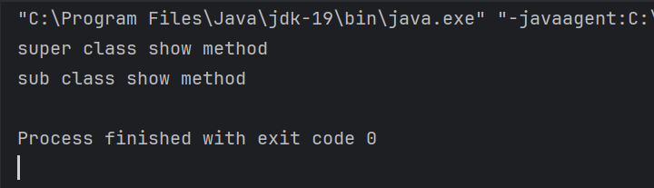
3)
What will be the output for the following code?
class Super
{
int num=20;
public void display()
{
System.out.println("super class method");
}
}
public class ThisUse extends Super
{
int num;
public ThisUse(int num)
{
this.num=num;
}
public void display()
{
System.out.println("display method");
}
public void Show()
{
this.display();
display();
System.out.println(this.num);
System.out.println(num);
}
public static void main(String[]args)
{
ThisUse o=new ThisUse(10);
o.Show();
}
}
OUTPUT:
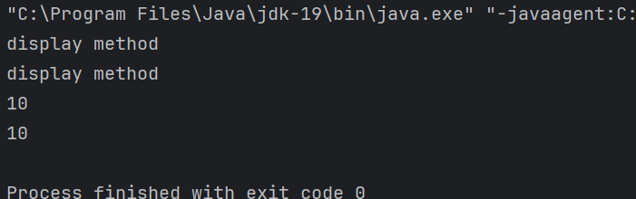
4) What is the singleton design pattern? Explain with a coding example.
A singleton ensures only one instance of a class exists and provides a global access point.
Code:
import java.io.*;
class Singleton{
private static Singleton instance;
private Singleton() {
System.out.println("Singleton is instantiated");
}
public static Singleton getInstance() {
if(instance == null)
instance=new Singleton();
return instance;
}
public void message() {
System.out.println("Hello");
}
}
class Main {
public static void main(String[] args) {
Singleton.getInstance().message();
}
}
OUTPUT:
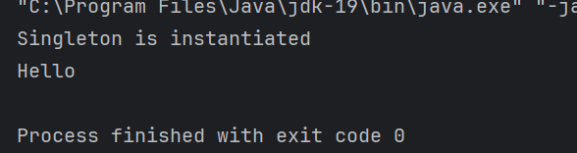
5) How do we make sure a class is encapsulated? Explain with a coding example.
To make sure the class is encapsulated, we need to declare the variables as private and method needs to be public to access and modify the private variable.
Code:
class Person {
private String name; //private variable
public String getName() { //public method
return name;
}
public void setName(String newName) {
this.name = newName;
}
}
public class Main {
public static void main(String[] args) {
Person myObj = new Person();
myObj.setName("Abc");
System.out.println(myObj.getName());
}
}

6)
Perform CRUD operation using ArrayList collection in an EmployeeCRUD class for the below Employee
class Employee{
private int id;
private String name;
private String department;
}
Code:
import java.util.ArrayList;
import java.util.*;
class Employee{
private int id;
private String name;
private String department;
public Employee (int id, String name, String department){
this.id=id;
this.name=name;
this.department=department;
}
public int getId(){
return id;
}
public String getName(){
return name;
}
public String getDepartment() {
return department;
}
public void setName(String name){
this.name=name;
}
public void setDepartment(String department) {
this.department = department;
}
public String toString() {
return "ID: " + id + ", Name: " + name + ", Department: " + department;
}
}
public class EmployeeCRUD {
ArrayList<Employee> list=new ArrayList<>();
//create
public void addEmployee(Employee e) {
list.add(e);
System.out.println("Employee added.");
}
//read
public void displayEmployees() {
if (!list.isEmpty()) {
//System.out.println("Employee List:");
for (Employee e : list) {
System.out.println(e);
}
}
}
//update
public void updateEmployee(int id, String newName, String newDept) {
for (Employee e : list) {
if (e.getId() == id) {
e.setName(newName);
e.setDepartment(newDept);
System.out.println("Employee updated.");
return;
}
}
System.out.println("Employee not found.");
}
//delete
public void deleteEmployee(int id) {
Iterator<Employee> iterator = list.iterator();
while (iterator.hasNext()) {
if (iterator.next().getId() == id) {
iterator.remove();
System.out.println("Employee deleted.");
return;
}
}
System.out.println("Employee not found.");
}
public static void main(String[] args) {
EmployeeCRUD emp = new EmployeeCRUD();
emp.addEmployee(new Employee(1,"Ram","HR"));
emp.addEmployee(new Employee(2, "Ravi", "Finance"));
System.out.println("Employees List");
emp.displayEmployees();
emp.updateEmployee(1, "Riya", "Marketing");
System.out.println("Employees List after updating");
emp.displayEmployees();
emp.deleteEmployee(2);
System.out.println("Employees List after deletion");
emp.displayEmployees();
}
}
OUTPUT:
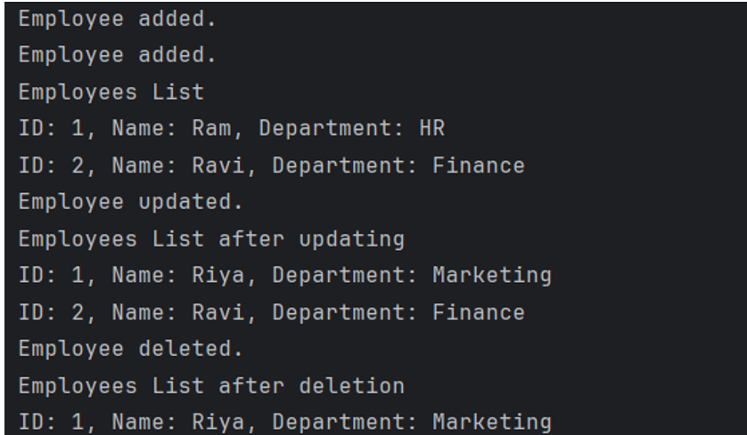
7) Perform CRUD operation using JDBC in an EmployeeJDBC class for the below Employee
class Employee{
private int id;
private String name;
private String department;
}
Code:
import java.sql.*;
public class EmpJDBC {
static final String DB_URL = "jdbc:mysql://localhost:3306/company";
static final String USER = "root";
static final String PASS = "root";
public void addEmployee(int id, String name, String dept) {
try (Connection conn = DriverManager.getConnection(DB_URL, USER, PASS);
PreparedStatement stmt = conn.prepareStatement("INSERT INTO employee VALUES (?, ?, ?)")) {
stmt.setInt(1, id);
stmt.setString(2, name);
stmt.setString(3, dept);
stmt.executeUpdate();
System.out.println("Employee added.");
} catch (SQLException e) {
e.printStackTrace();
}
}
public void displayEmployees() {
try (Connection conn = DriverManager.getConnection(DB_URL, USER, PASS);
Statement stmt = conn.createStatement();
ResultSet rs = stmt.executeQuery("SELECT * FROM employee")) {
while (rs.next()) {
System.out.println("ID: " + rs.getInt("id") +
", Name: " + rs.getString("name") +
", Dept: " + rs.getString("department"));
}
} catch (SQLException e) {
e.printStackTrace();
}
}
public void updateEmployee(int id, String name, String dept) {
try (Connection conn = DriverManager.getConnection(DB_URL, USER, PASS);
PreparedStatement stmt = conn.prepareStatement("UPDATE employee SET name=?, department=? WHERE id=?")) {
stmt.setString(1, name);
stmt.setString(2, dept);
stmt.setInt(3, id);
int rows = stmt.executeUpdate();
if (rows > 0)
System.out.println("Employee Updated.");
else
System.out.println("Not found.");
} catch (SQLException e) {
e.printStackTrace();
}
}
public void deleteEmployee(int id) {
try (Connection conn = DriverManager.getConnection(DB_URL, USER, PASS);
PreparedStatement stmt = conn.prepareStatement("DELETE FROM employee WHERE id=?")) {
stmt.setInt(1, id);
int rows = stmt.executeUpdate();
if (rows > 0)
System.out.println("Employee Deleted.");
else
System.out.println("Not found.");
} catch (SQLException e) {
e.printStackTrace();
}
}
public static void main(String[] args) {
EmpJDBC obj = new EmpJDBC();
obj.addEmployee(1, "Ram", "HR");
obj.addEmployee(2, "Bob", "IT");
obj,addEmployee(3, "Ram", "HR");
System.out.println("Employees:");
obj.displayEmployees();
obj.updateEmployee(1, "Riya", "Finance");
System.out.println("Employees after update:");
obj.displayEmployees();
obj.deleteEmployee(2);
System.out.println("Employees after deletion:");
obj.displayEmployees();
}
}
OUTPUT:
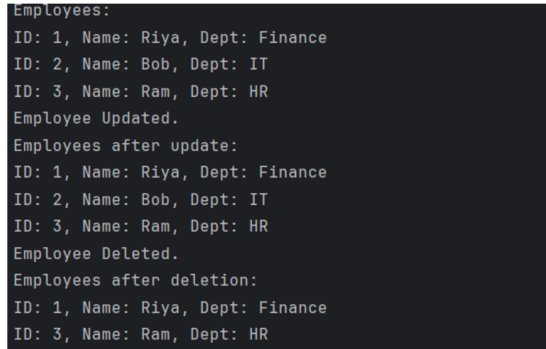

JAVASCRIPT:

OUTPUT:

